Laycee Glass

NBM3 Task 1

Predictive Modeling

10/7/24

Western Governors University

## NBM3 Performance Assessment, Task 1

### Student Information

Student Name: Laycee Glass

ID Number: 001896026

Date: 10/7/2024

### Part I: Research Question

### A1. Question

The research question I chose to answer was the following: “What factors contribute most to total charge of patients during a hospital admission?”

### A2. Goals of Analysis

While the above question may seem broad in nature, it can lead to some quality insights for hospitals. By answering this question using multiple linear regression, it may help the hospital forecast costs. They would be able to identify contributing cost factors to help with estimating future expenses. In turn, this would allow for better budgeting.

The overall goals for this analysis would be to identify which variables have the most influence on the variable TotalCharge and develop a model to predict the total charge of patients based on certain attributes.

### Part II: Method Justification

### B1. Assumptions

When working with multiple linear regression, there are a few assumptions for the data we are using. These assumptions are the following (Bobbitt, 2021):

1. Linearity: The relationship between the dependent variable and each independent variable should be linear. If it is not linear, it may not accurately reflect the effect of each and can introduce bias.
2. Independence: Observations should be independent of one another. No observations should be reliant on previous ones.
3. Homoscedasticity: Variance of the residuals should be constant across all independent variables. If the variance is not constant, the model may give considerable weight to larger residuals and effect estimates. This can also introduce bias.
4. Normality: Residuals should be normally distributed. Non-normal distributions can affect validity of t-tests, which can affect the inferences one can make about the significance of coefficients
5. Multicollinearity: Independent variables should not be highly correlated with each other. If there is a high correlation, this makes it difficult to isolate the effect of predictor variables, which can make the model unstable.

### B2. Benefits of Python

For this assessment, I used Python. Python is my preferred programming language as it has comprehensive libraries and tools that make performing analysis tasks, especially the tasks for this assessment, efficient. The following libraries were used:

* NumPy – offers support for mathematical functions and computations
* Pandas – makes data manipulation easy
* SciPy – has modules for advanced statistical analysis
* Statsmodels – provides functions for estimating and analyzing models
* Matplotlib, seaborn – data visualization
* Scikit-learn – machine learning library with specific tools for regression, as well as a consistent API for model building and evaluation

Another reason for choosing Python was specifically for its data visualizations. As stated above, matplotlib and seaborn are very effective for creating custom models that are easy to create and interpret.

### B3. Justification

Multiple linear regression was appropriate here because it explores the relationships between a continuous, dependent variable (total charge) and multiple independent variables. Single linear regression would not be ideal as it can’t examine as many variables, especially with how many variables we have for this task. Logistic regression would not work because it is used when the dependent variable is categorical, which ours is not (Bruce et al., 2020).

### Part III: Data Preparation

### C1. Data Cleaning Process

In order to perform the linear regression, some data cleaning needed to take place. The goals of data cleaning were to detect and treat any null values and duplicates. Outliers were identified but also retained as these values were ‘expected.’ Finally, unnecessary columns were dropped for the final csv file to be exported.

The following is the code I used to achieve these goals:

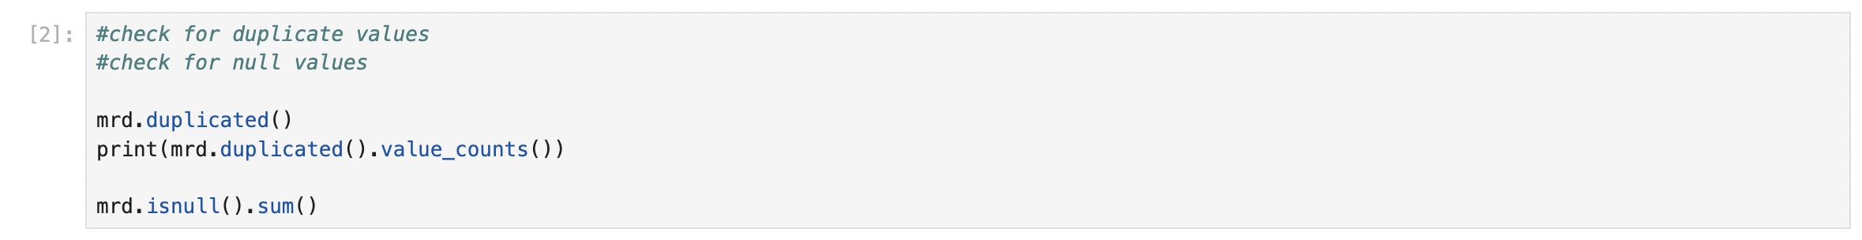

### C2. Summary Statistics

The dependent variable (x) for the question posed was TotalCharge, whereas the independent variables (y) were the following: Children, Age, Income, VitD_levels, Doc_visits, Full_meals_eaten, VitD_supp, HighBlood, Stroke, Overweight, Arthritis, Diabetes, Hyperlipidemia, BackPain, Anxiety, Allergic_rhinitis, Reflux_esophagitis, Asthma, and Initial_days.

The following is the code used to get the summary statistics for these variables, along with their outputs:

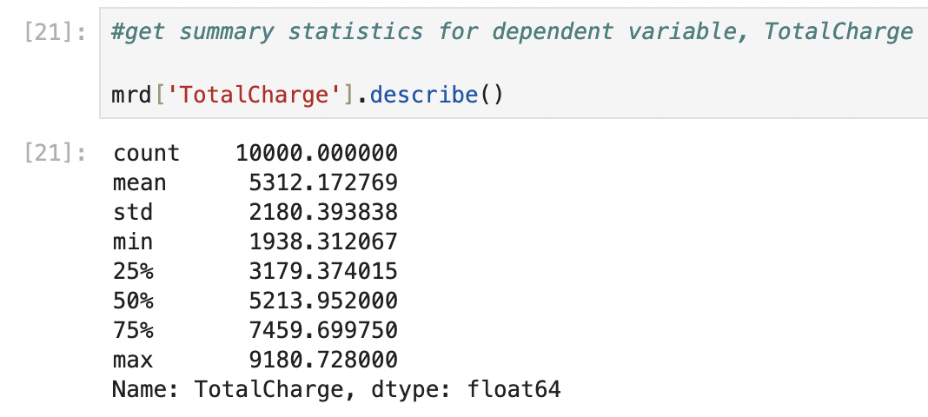

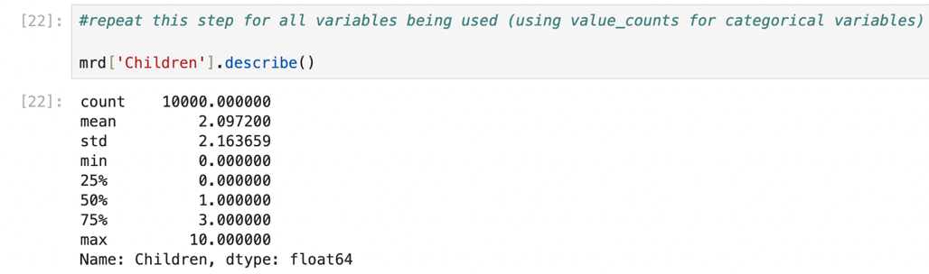

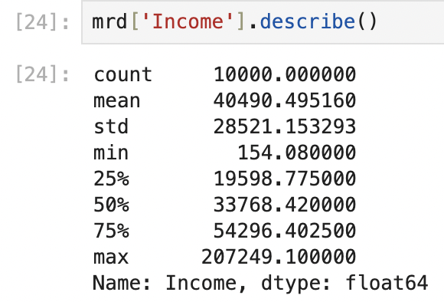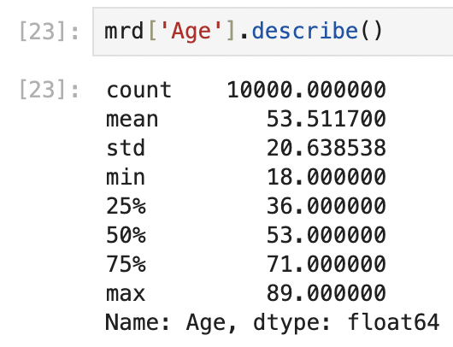

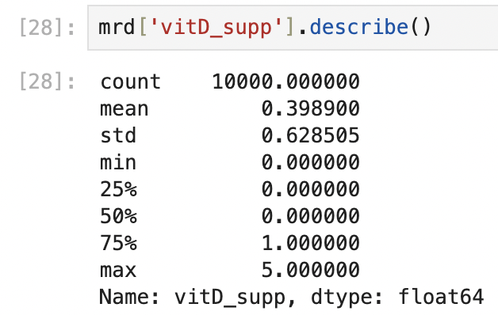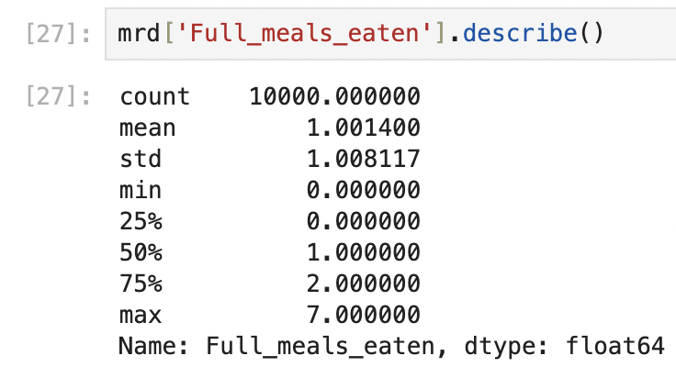

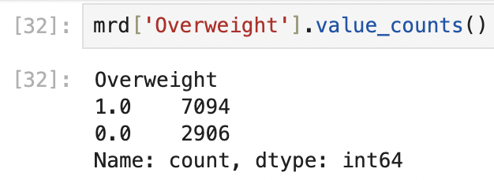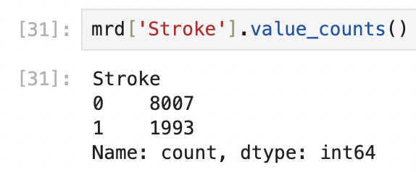

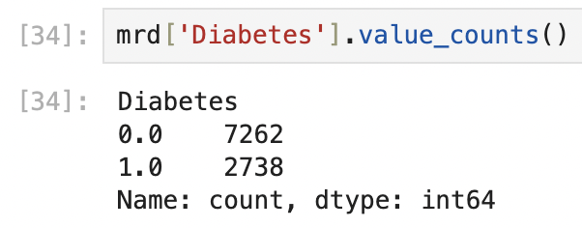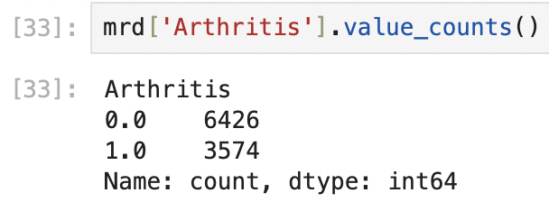

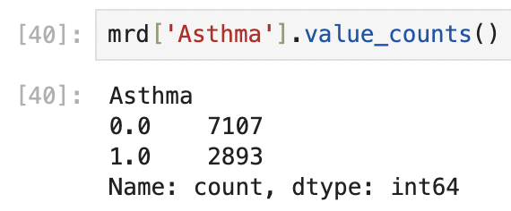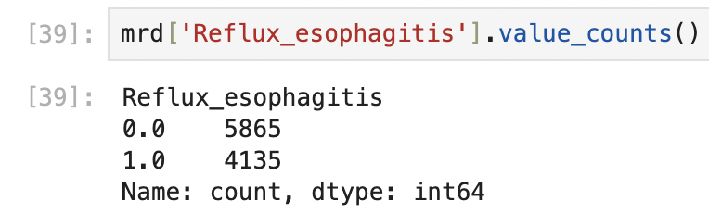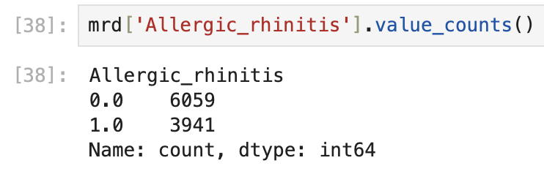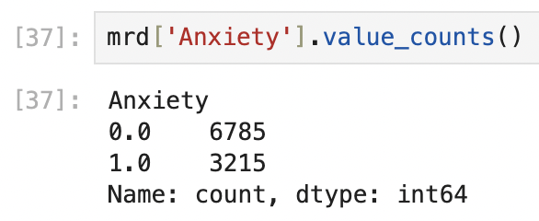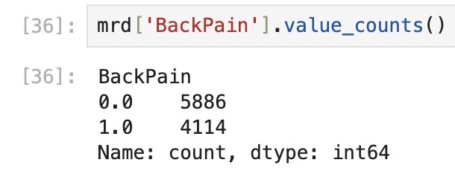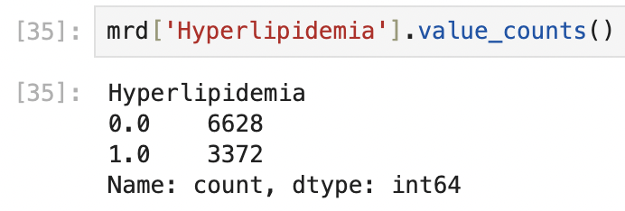

All variables had a count of 10000.

TotalCharge: The minimum was $1938.31 and the maximum was $9180.73. The average total charge was $5312.17.

Children: The minimum was 0 and the maximum was 10. The average number of children was 2.08.

Age: The minimum was 18 and the maximum was 89. The average age was 53.5.

Income: The minimum was $154.08 and the maximum was $207249.10. The average income was $40490.50.

VitD_levels: The minimum was 9.81 and the maximum was 26.39. The average Vitamin D level was 17.96.

Doc_visits: The minimum was 1 and the maximum was 9. The average number of doctor visits was 5.01.

Full_meals_eaten: The minimum was 0 and the maximum was 7. The average number of full meals eaten was 1.

vitD_supp: The minimum was 0 and the maximum was 5. The average number of Vitamin D supplements was 0.40.

Initial_days: The minimum was 1 and the maximum was 71.98. The average number of days initially spent in the hospital was 34.46.

HighBlood: 40.9% of patients had high blood pressure.

Stroke: 19.93% of patients had a stroke.

Overweight: 70.94% of patients were overweight.

Arthritis: 35.74% of patients had arthritis.

Diabetes: 27.38% of patients had diabetes.

Hyperlipidemia: 33.72% of patients had hyperlipidemia.

BackPain: 41.14% of patients had back pain.

Anxiety: 32.15% of patients had anxiety.

Allergic_rhinitis: 39.41% of patients had allergic rhinitis.

Reflux_esophagitis: 41.35% of patients had reflux esophagitis.

Asthma: 28.93% of patients had asthma.

### C3. Univariate and Bivariate Visualizations

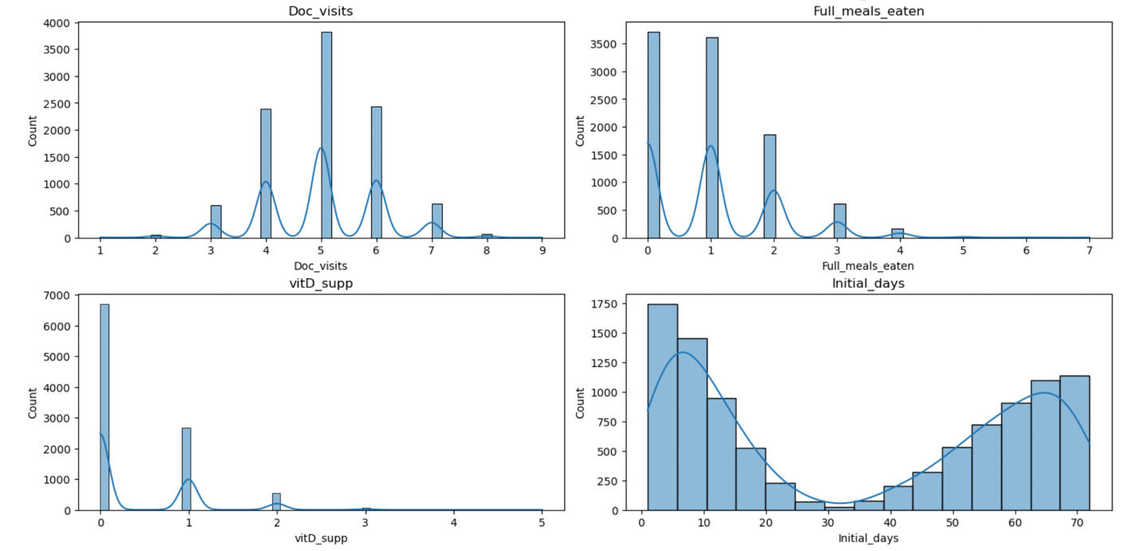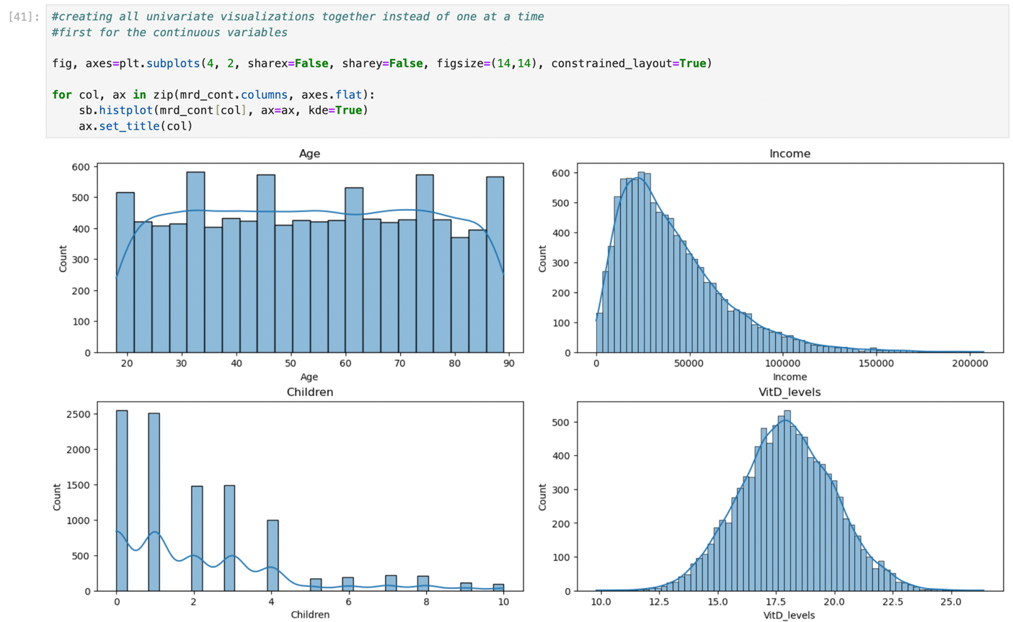The following is the code, and subsequent charts, used to create the univariate visualizations for the continuous variables and categorical variables, respectively:

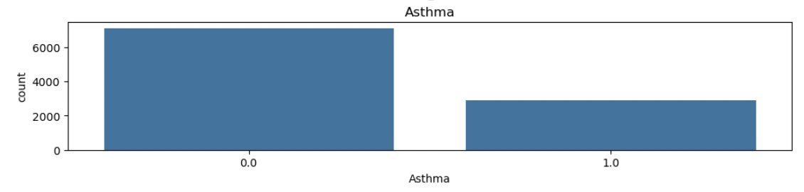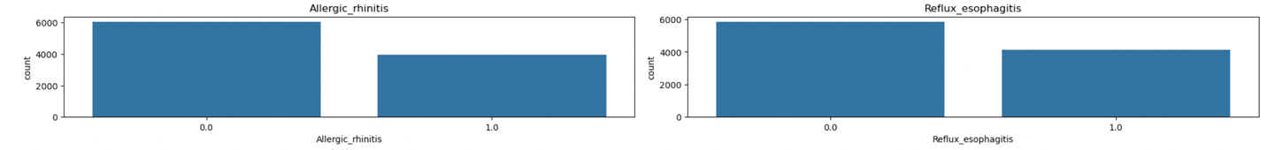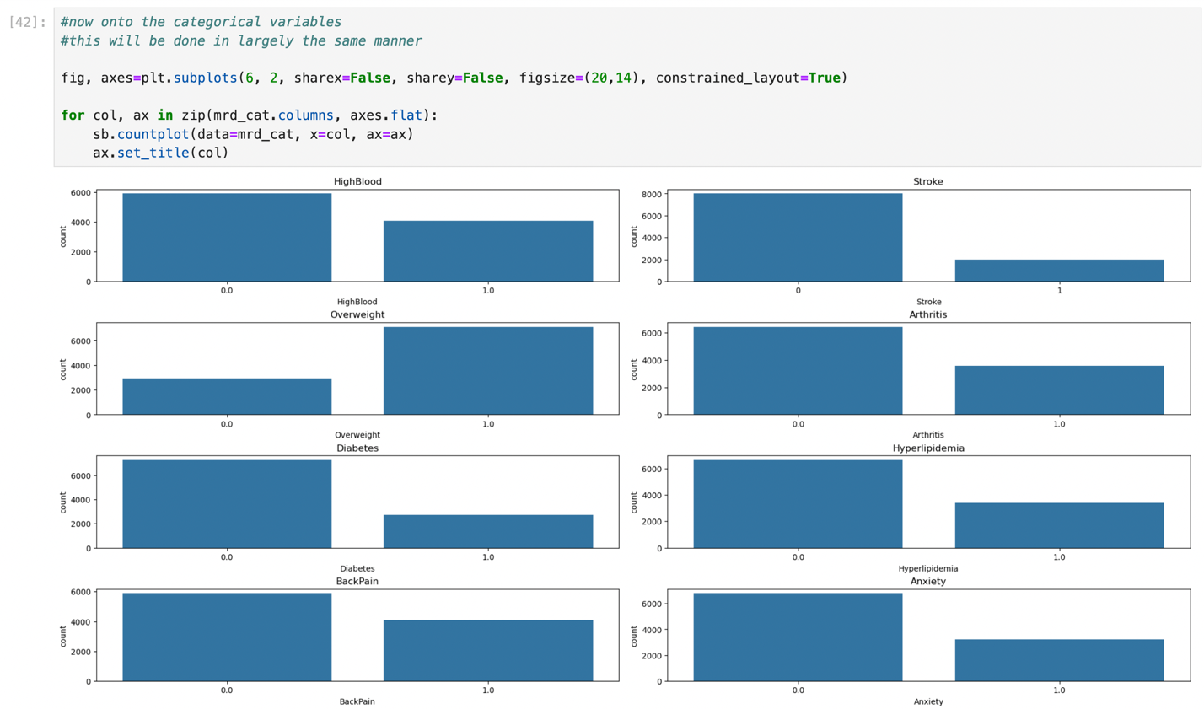

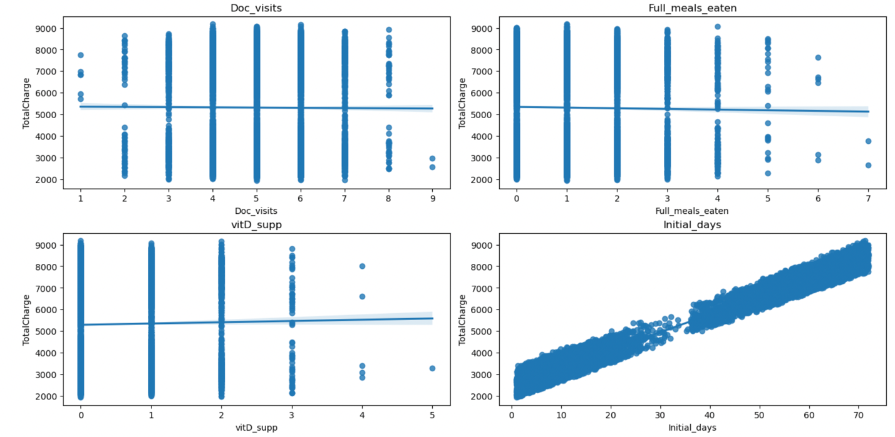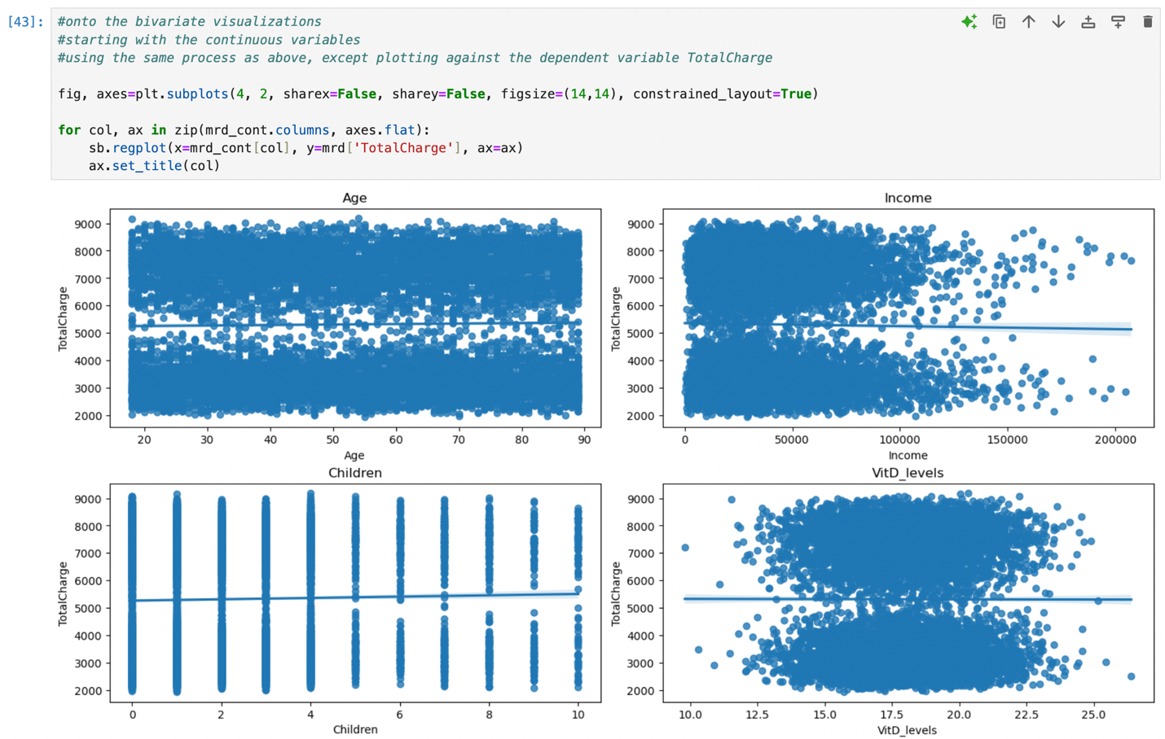The following is the code, and subsequent charts, used to create the bivariate visualizations for the continuous variables and categorical variables, respectively:

### C4. Data Transformation Goals

For the purpose of this task, the only transformation that took place was re-expression of categorical variables using the .map function. The variables HighBlood, Stroke, Overweight, Arthritis, Diabetes, Hyperlipidemia, BackPain, Anxiety, Allergic_rhinitis, Reflux_esophagitis, and Asthma were re-expressed by mapping “Yes” values to 1 and “No” values to 0.

The following is the code used to perform this transformation:

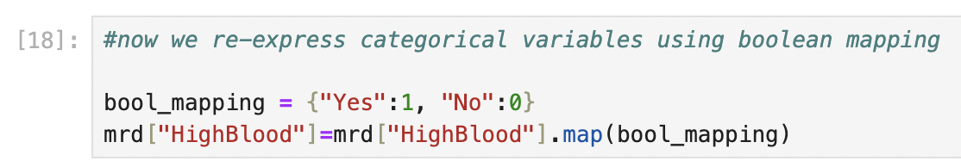

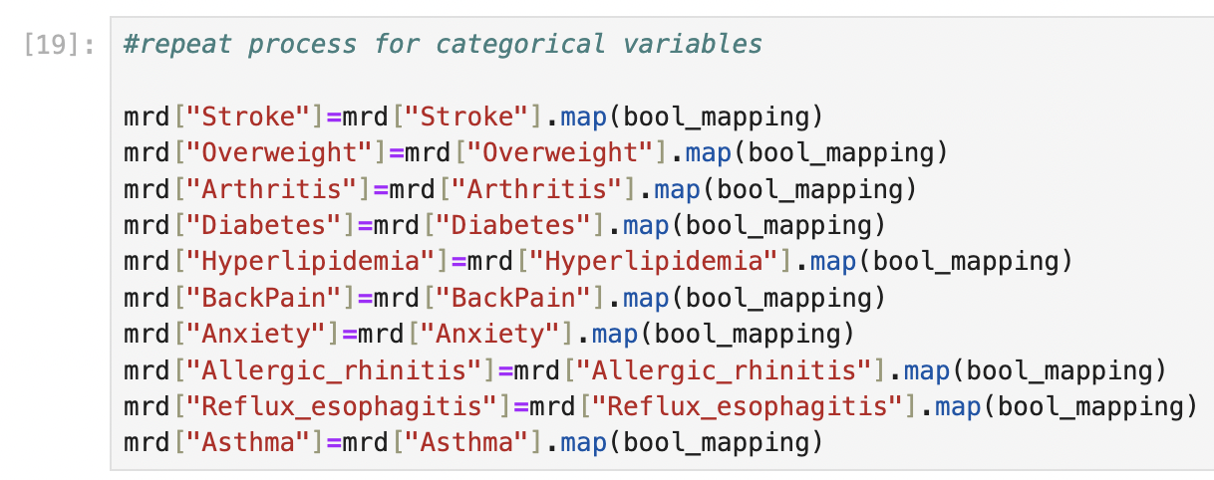

### C5. CSV File

The cleaned dataset was submitted alongside this document as part of the task submission. The data was exported as a CSV file using the following code:

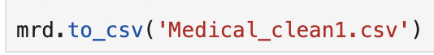

### Part IV: Model Comparison and Analysis

### D1. Initial MLR Model

The initial regression model was constructed using the variables named in section C2. It was created using the .assign(const=1) function. This was done to add the intercept term directly to the DataFrame. The initial model had 19 variables that was eventually reduced to focus on the most meaningful variables to the dependent variable.

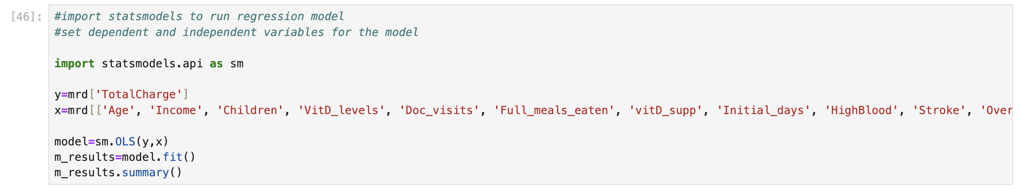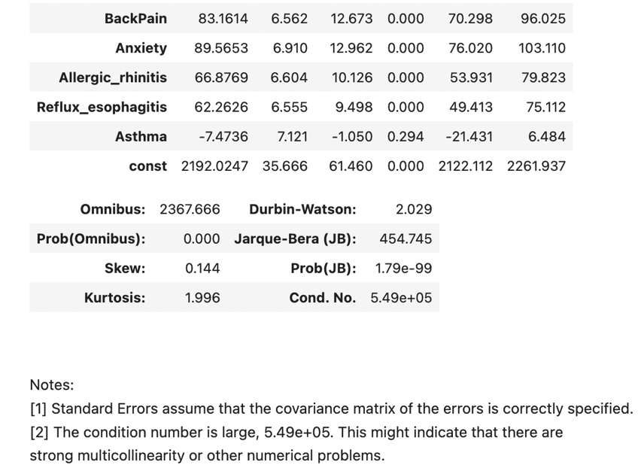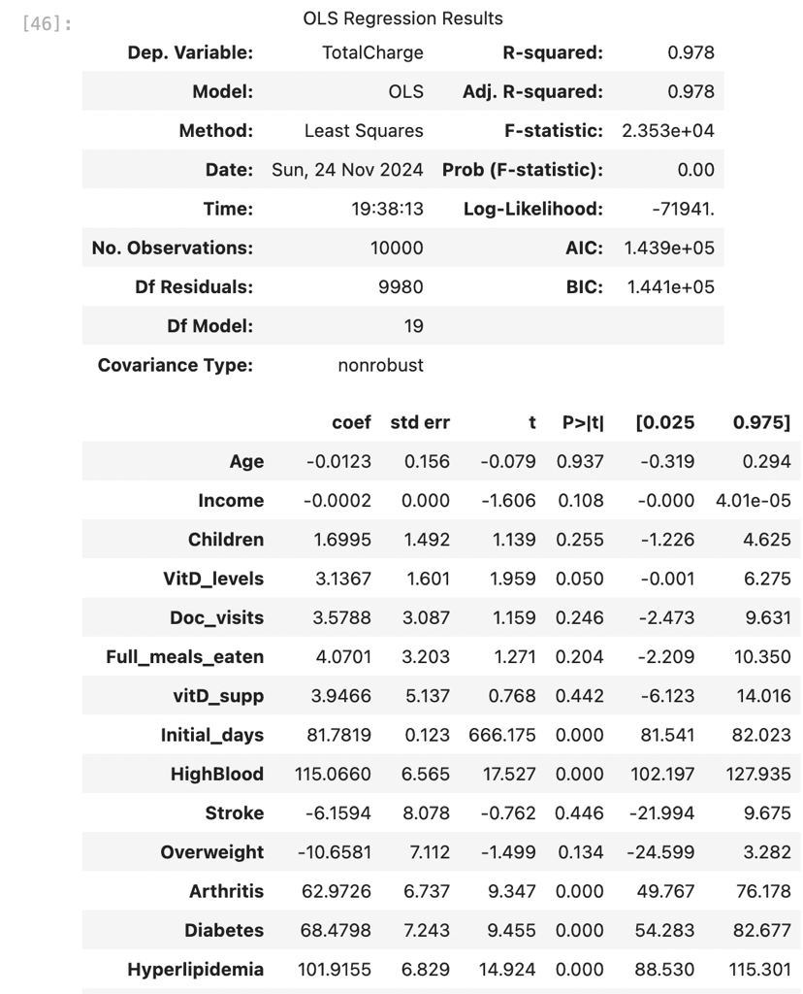The following is the code used to generate this model and its output (Keith, 2021):

### D2. Feature Selection

As shown in the output of the code above, there were multicollinearity issues that might have present. For this reason, variance inflation factor (VIF) was used to eliminate variables. There were 3 variables that were eliminated through this process, as their VIF was greater than 5 and indicated high multicollinearity. Once that was complete, backwards elimination was used to reduce the model further based on p-values. Variables whose p-values were greater than 0.05 were eliminated as they were not statistically significant. This resulted in 6 more variables being removed from the model.

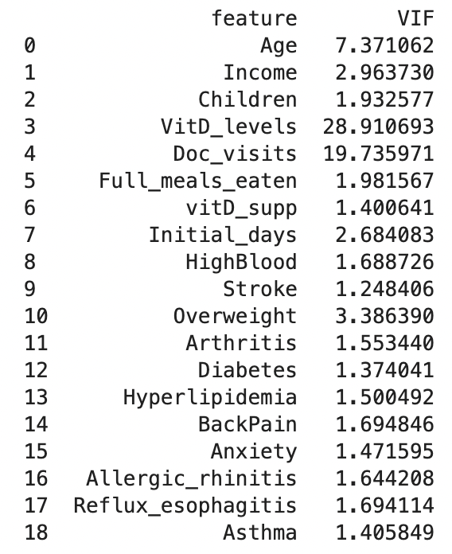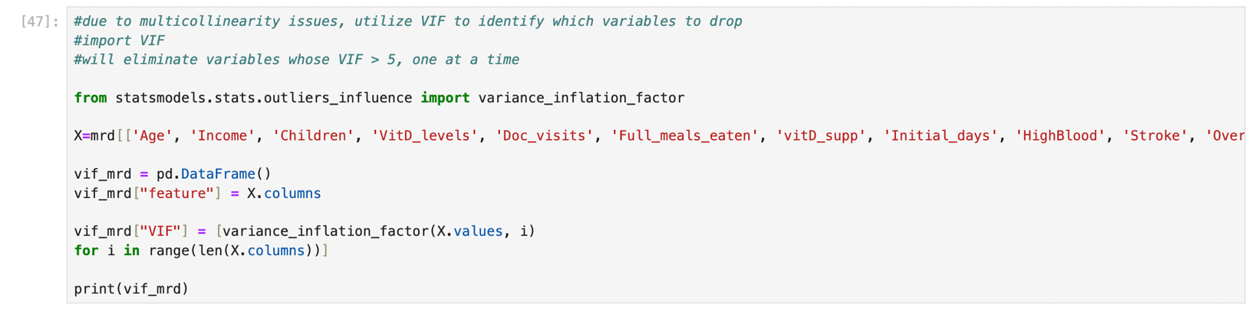The following code was used for the VIF process as stated above (GeeksforGeeks, 2024):

The code was then repeated after each variable removal. The following was the code used for the backwards elimination process:

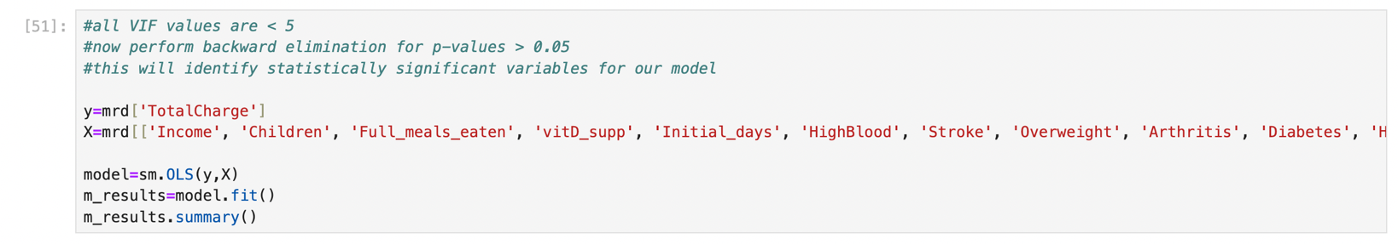

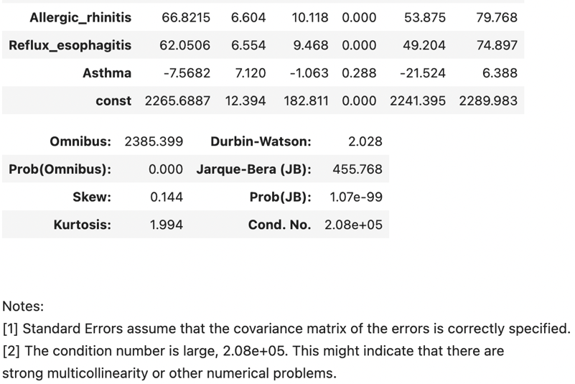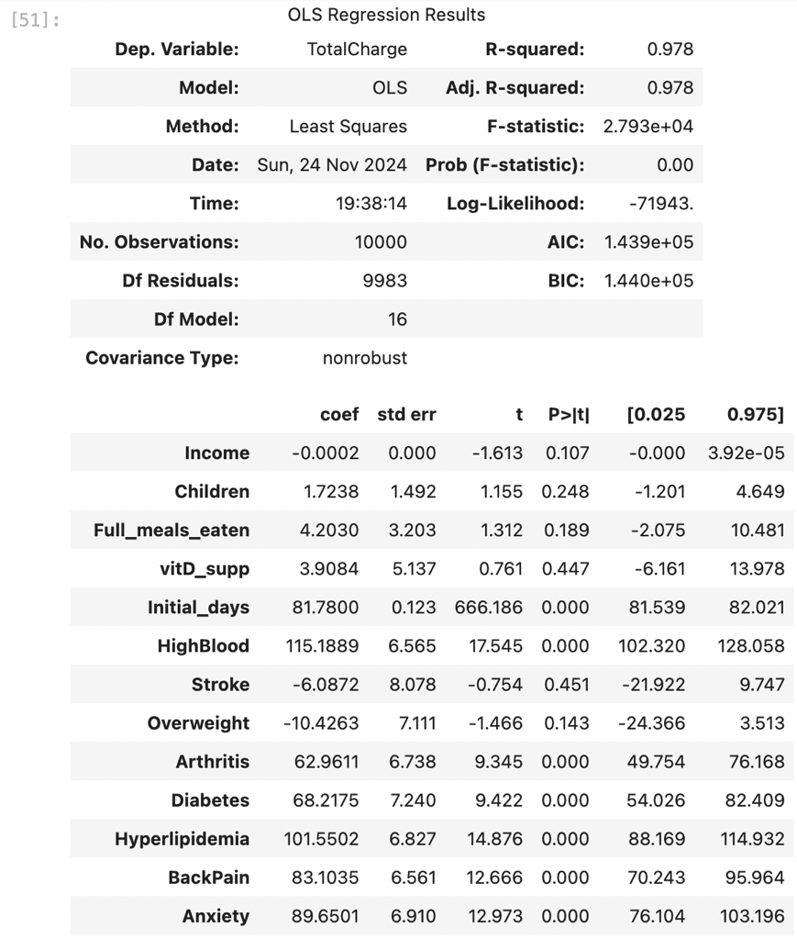

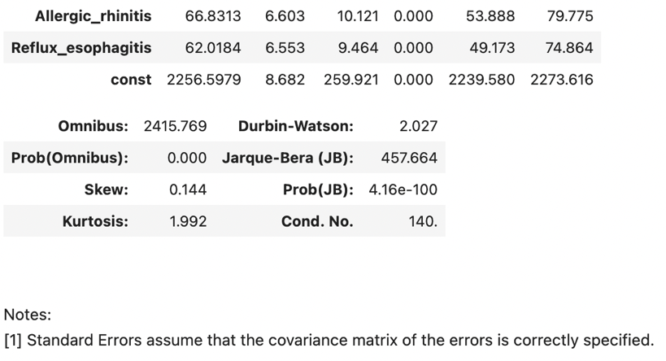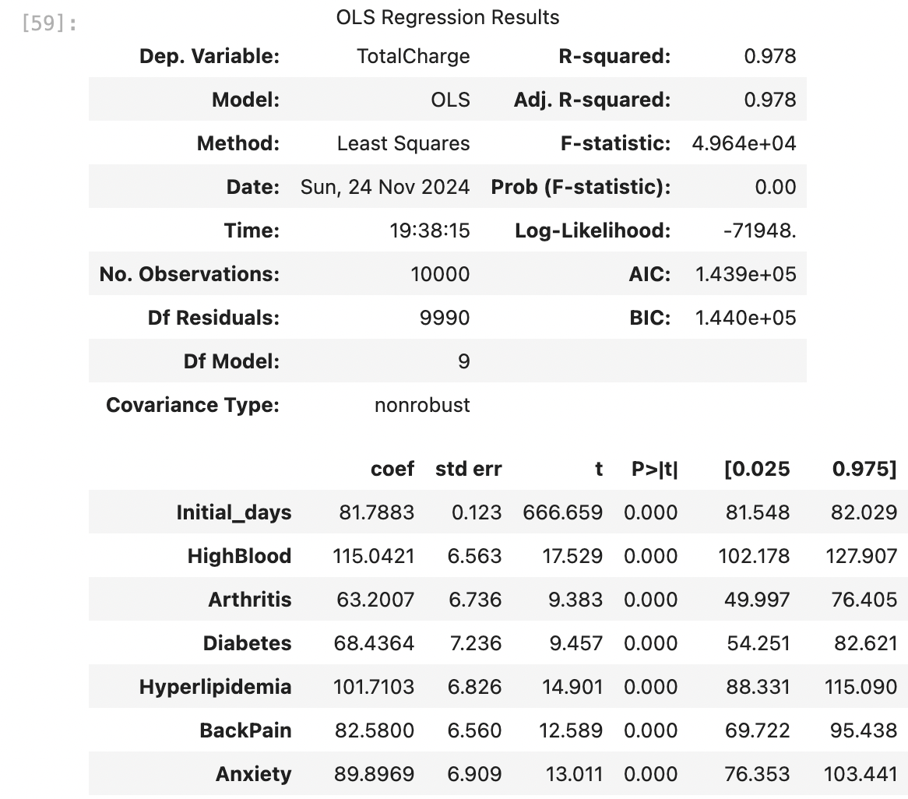This was repeated again, removing each variable greater than 0.05 until the following model was left:

### D3. Reduced MLR Model

The final, reduced model is shown above. The variables that remained, seemingly most significant to the dependent variable, were Initial_days, HighBlood, Arthritis, Diabetes, Hyperlipidemia, BackPain, Anxiety, Allergic_rhinitis, and Reflux_esophagitis.

### E1. Model Comparison

The initial regression model that was created had many variables, most of which ended up not being important to the model itself. Over half were eliminated due to either multicollinearity concerns or statistical insignificance.

Both the initial and the reduced model had high r-squared values, so a different metric was used to compare these models – the F statistic. The reduced model ended up having a much higher F statistic (2.353e+04) when compared to the initial model (4.964e+04). This indicates, generally, that the model is more statistically significant. Overall, it suggests that a model with no predictors is worse than the created model (Kumar, 2023).

### E2a. Residual Plot

Residual plots were created for each variable contained in the reduced model. The following is the code and subsequent plots generated by such (GeeksforGeeks, 2022):

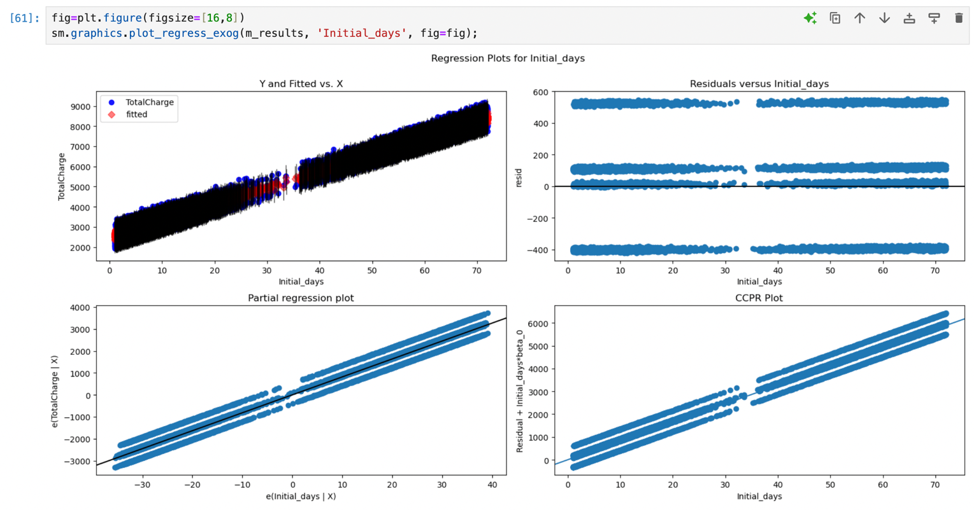

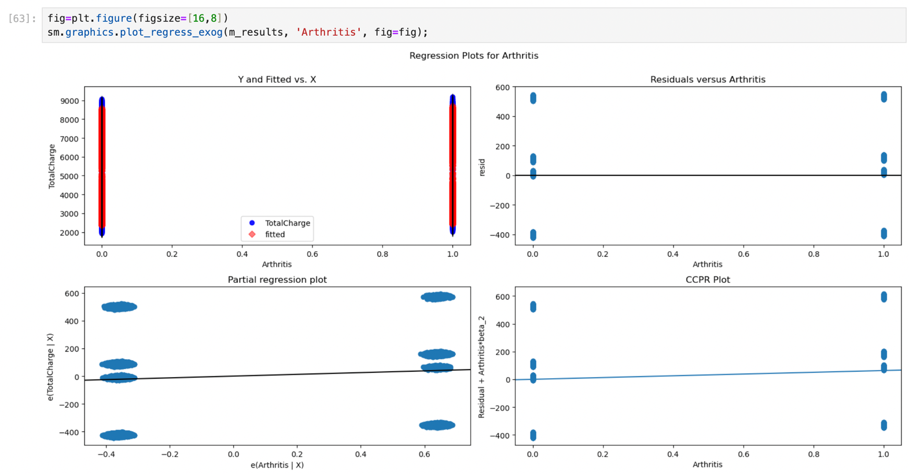

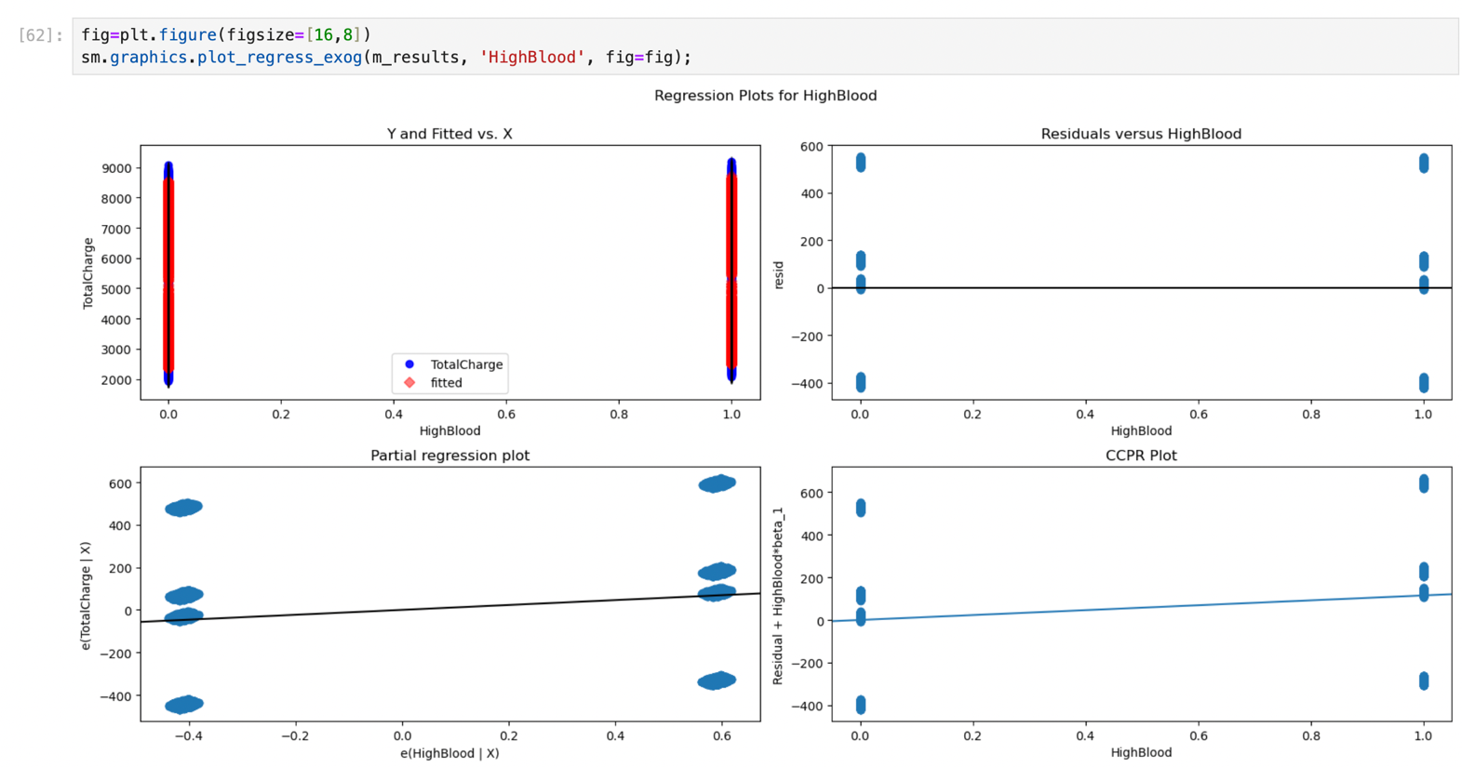

### E2b. Residual Standard Error

The residual standard error for the reduced model was found to be 322. The following is the code used to calculate this number:

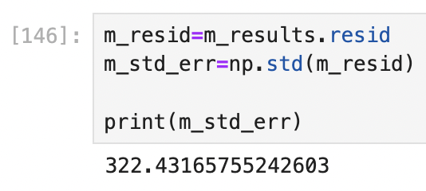

### E3. Code

The code for each portion of this task has been shown previously within this document, as well as attached in the .ipynb file.

### Part V: Data Summary and Implications

### F1a. Regression Equation

*y* = 2256.5979 + (81.7883 * Initial_days) + (115.0421 * HighBlood) + (63.2007 * Arthritis) + (68.4364 * Diabetes) + (101.7103 * Hyperlipidemia) + (82.5800 * BackPain) + (89.8969 * Anxiety) + (66.8313 * Allergic_rhinits) + (62.0184 * Reflux_esophagitis)

### F1b. Coefficient Interpretation

According to the equation listed above, for each additional initial day of stay during an admission to the hospital, the total charge increases by $81.79 on average. This assumes all other factors remain constant.

If a patient has been diagnosed with high blood pressure, the total charge increases by $115.04.

If a patient has been diagnosed with arthritis, the total charge increases by $63.20.

If a patient has been diagnosed with diabetes, the total charge increases by $68.44.

If a patient has been diagnosed with hyperlipidemia, the total charge increases by $101.71.

If a patient has back pain, the total charge increases by $82.58.

If a patient has been diagnosed with anxiety, the total charge increases by $89.90.

If a patient has been diagnosed with allergic rhinitis, the total charge increases by $66.83.

If a patient has been diagnosed with reflux esophagitis, the total charge increases by $62.02.

From this, it appears that hyperlipidemia has the largest positive effect, meaning that these patients tend to receive the highest total charges on average. In contrast, reflux esophagitis has the smallest effect of the listed conditions.

### F1c/d. Reduced Model Significance and Disadvantages

Our model would be considered statistically significant based on its high F statistic, coupled with the probability of its F statistic being 0 (less than the threshold of 0.05). Regarding practical significance, this model definitely lacks insight. The small sample size and particular demographics (no children included) may not lend to generalizations in other settings.

Also, when looking at the regression equation, a $68 increase in total charge may not be impactful when talking about hospital bills which can bleed into thousands (and much more!) of dollars. Other variables that are not listed in this data would have far greater impact, such as insurance policies of patients and the severity of their diagnosis/illness.

A limitation in our specific case here is that models with more than 5 independent variables need to be concerned about multicollinearity. While we took steps to combat this using VIF, there is still a greater chance that the independent variables are correlated amongst each other.

### F2. Recommendations

As the model lacks practical significance, my recommendation would be to gather even more data and include more variables. More data would lead to better generalization between healthcare settings. As noted, there were no children in our dataset, which is not representative of the population. For more variables, I would recommend also getting data on patient insurances and a severity scale. These, I imagine, would have more significance to the charges a patient receives while in the hospital.

### Part VI: Demonstration

### G. Panopto Recording

A Panopto recording has been attached with this paper.

### H. Code Sources

GeeksforGeeks. (2024, October 14). *Detecting multicollinearity with VIF - python*. https://www.geeksforgeeks.org/detecting-multicollinearity-with-vif-python/

GeeksforGeeks. (2022, February 21). *How to create a residual plot in Python*. https://www.geeksforgeeks.org/how-to-create-a-residual-plot-in-python/

Keith, M. (2021, October 11). *Python: Intro to MLR / OLS in statmodels.api*. YouTube. https://www.youtube.com/watch?v=0-fkgpK2knA&t=2s

### I. Sources

Bobbitt, Z. (2021, January 21). *The four assumptions of linear regression*. Statology. https://www.statology.org/linear-regression-assumptions/

Bruce, P. C., Bruce, A., & Gedeck, P. (2020). *Practical statistics for data scientists: 50+ essential concepts using r and python*. O’Reilly Media, Inc.

Kumar, A. (2023, December 11). *F-Test & F-statistics in linear regression: Formula, examples*. Analytics Yogi. https://vitalflux.com/interpreting-f-statistics-in-linear-regression-formula-examples/